# Computer Vision Hw4 Report

* Discription
  + Mathematical Morphology - Binary Morphology
* Algorithm
  + Kernel of Hit and Miss

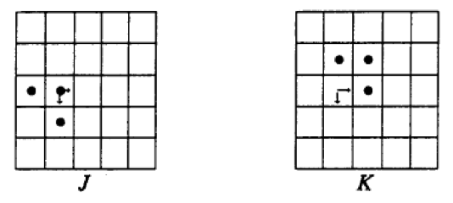

* + Kernel of dilation, erosion, opening and closing

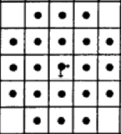

* Parameters (if any)
  + no
* Principal Code Fragment

Main

(file – /src/hw4/ DemoBinaryMorphology.java)

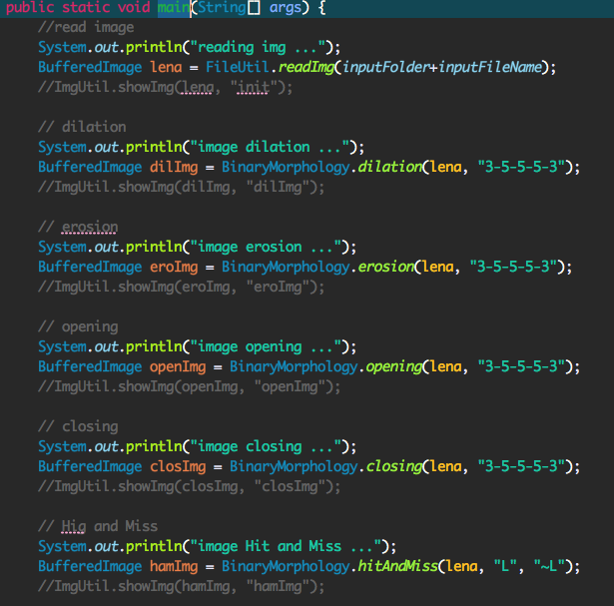

Dilation

(file – /src/cv1.util.cv / BinaryMorphology.java)

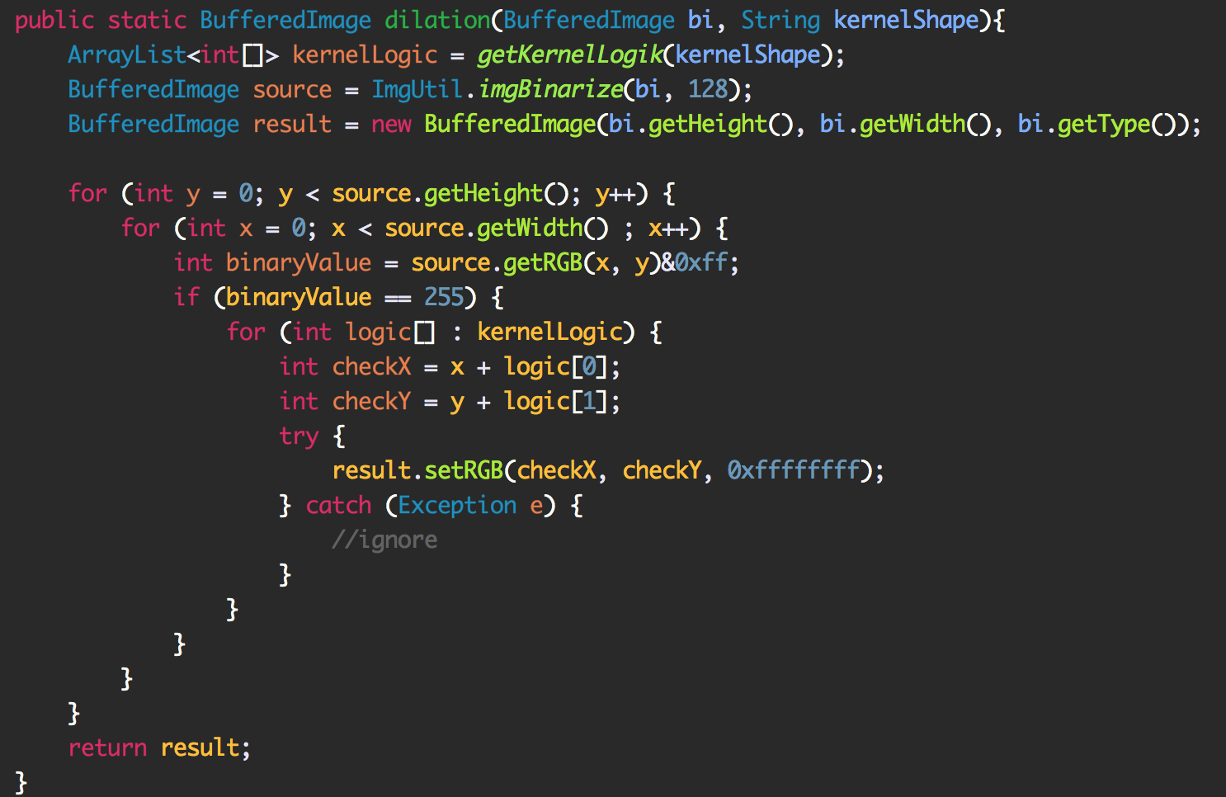

Erosion

(file – /src/cv1.util.cv / BinaryMorphology.java)

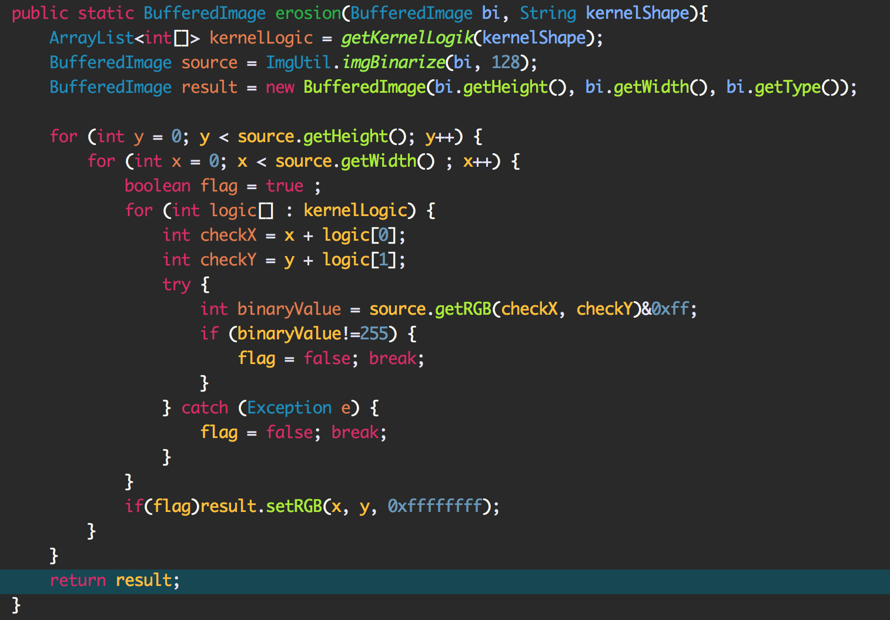

Opening and Closing

(file – /src/cv1.util.cv / BinaryMorphology.java)

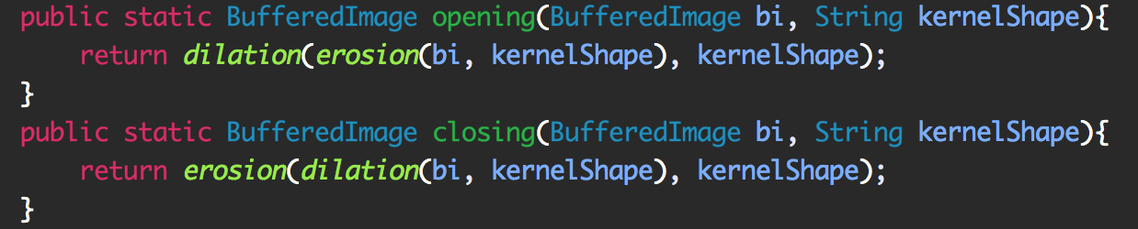

Hit and Miss

(file – /src/cv1.util.cv / BinaryMorphology.java)

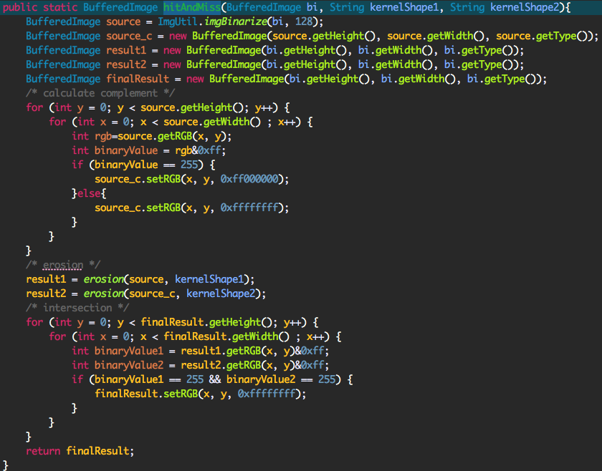

* Result Image

Dilation Erosion

 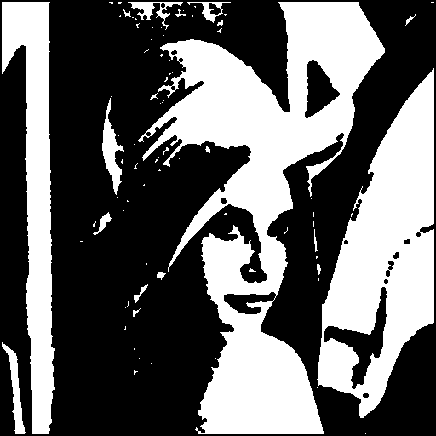

Opening Closing

 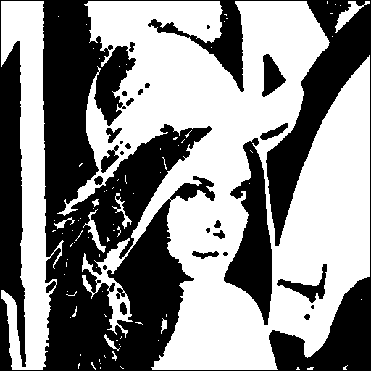

Hit and Miss

